SQL ASSIGNMENT -6

ROLL NO-84016

Q1.Write two different queries that would produce all orders taken on October 3rd or 4th ,1990.
Ans.
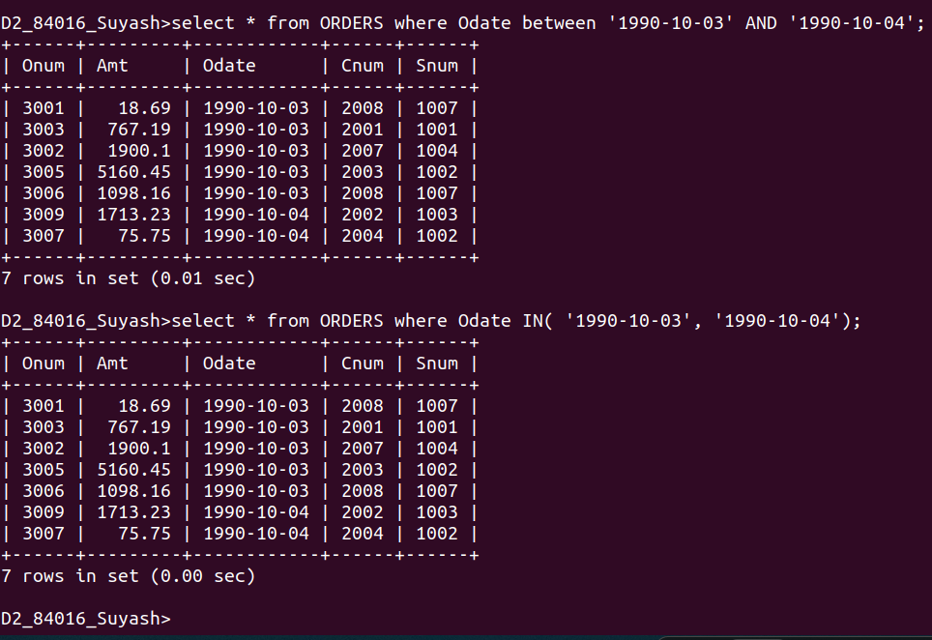

Q2.Write a query that selectus all of the customers serviced by peel or Motika .(Hint:the Snum filed relates the two tables to one another).
Ans.
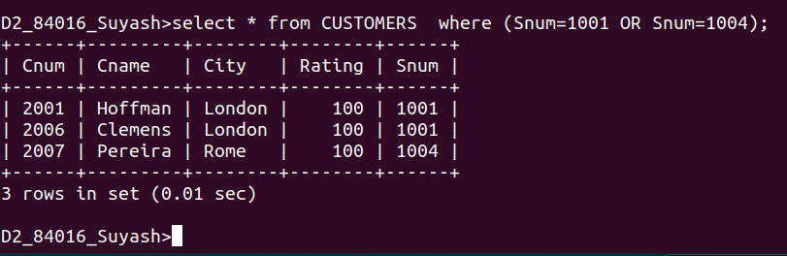

Q3.Write a query that will produce all the Customers whose names begin with a letter from ‘A’ to ‘G’
Ans.
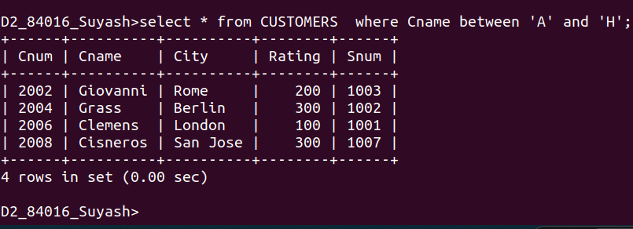

Q4.Write will be that will produce all the customers whose names begin with the letter from ‘c’.
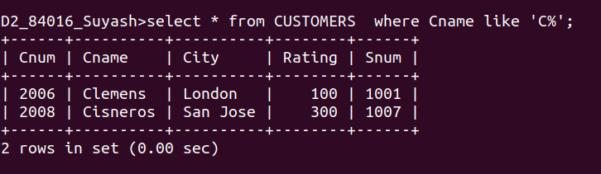
Ans.

Q5.Write a query that selectus all orders expcet those with zeroes or NULL in the amt field.
Ans.
